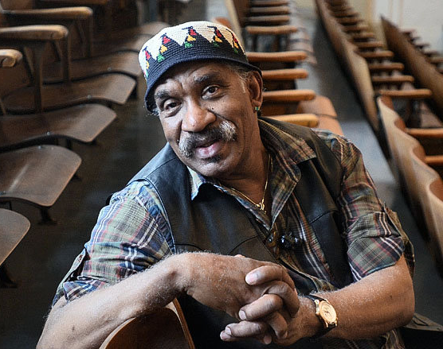

Garth Fagan

Critics have hailed Garth Fagan as a “trail blazer” and “one of the great reformers of modern dance.” With an incomparable style that blends the weight of modern dance, the vibrancy of Afro-Caribbean dance, the speed and precision of ballet and the risk-taking experimentation of post-modernism, he has created more than 70 works for the theater and concert stage.

His works defy classification and range from his ground-breaking choreography for the hit musical The Lion King to Griot New York and Lighthouse/Lightning Rod, his critically acclaimed collaborations with Pulitzer-Prize-winning composer Wynton Marsalis. Although he choreographs primarily for Garth Fagan Dance, he has also created pieces for other leading companies, including Alvin Ailey American Dance, Dance Theatre of Harlem, New York City Ballet and the Limón Dance Company.

To date, he has received over 60 major awards and honors for his work. The Dance Heritage Coalition recently added his name to its list of 100 Irreplaceable American Dance Treasures. For his choreography of The Lion King, he has won every important award given to theater artists, including Broadway’s prestigious Tony Award, London’s Olivier Award and Australia’s Helpmann Award.

Born in Kingston, Jamaica, Mr. Fagan began performing with Ivy Baxter’s Jamaican National Dance Company while he was still in high school. In 1960, he came to the United States and earned a degree in psychology from Detroit’s Wayne State University. He considered becoming a psychologist but instead moved to New York, where he studied with Martha Graham, Alvin Ailey and José Limon, and performed with Pearl Primus and Lavania Williams.

In 1969, he was invited to join the faculty of the State University of New York at Brockport. Inspired by his work with the underprivileged students he met while teaching SUNY-affiliated classes in Rochester, he established his own company in 1970. Founded as Bottom of the Bucket But… Dance Theatre to reflect its unassuming origins, he changed the name of the company in 1991 to Garth Fagan Dance.

Now approaching its fifth decade under his determined leadership, Garth Fagan Dance is an internationally acclaimed company, a school that annually provides dance training to over 450 students, and an innovative outreach program designed to serve the greater Rochester community through educational performances and dance instruction.

